**Assignment -4**

Python Programming

|  |  |
| --- | --- |
| Assignment Date | 02 November 2022 |
| Student Name | MAGESWARI S |
| Student Roll Number | 19103054 |
| Maximum Marks | 2 Marks |

**Question-1:**

Write code and connections in wokwi for the ultrasonic sensor. Whenever the distance is less than 100 cms send an "alert" to the IBM cloud and display in the device recent events. Upload document with wokwi share link and images of IBM cloud. **Solution:**

const int TRIG_PIN = 7 ; const int ECHO_PIN = 8; const unsigned int MAX_DIST = 23200;

void setup() { pinMode(TRIG_PIN, OUTPUT); digitalWrite(TRIG_PIN, LOW); pinMode(ECHO_PIN, INPUT ) ;

Serial.begin(9600);

}

void loop() { unsigned long t1; unsigned long t2; unsigned long pulse_width; float cm; float inches; digitalWrite(TRIG_PIN, HIGH); delayMicroseconds(10); digitalWrite(TRIG_PIN, LOW); while (digitalRead( ECHO_PIN )==0 ); t1= micros ();

while (digitalRead(ECHO_PIN) == 1); t2= micros (); pulse_width = t2-t1; cm=pulse_width / 58 ; inches = pulse_width/148.0; if (pulse_width >MAX_DIST){

Serial.println("Out of range");

} else {

Serial.println("***********");

Serial.print("The Measured Distance in cm: "); Serial.println(cm); if( cm < 100 ){

Serial.println("Alert!!");

}

Serial.print("*************");

}

delay(1000);

}

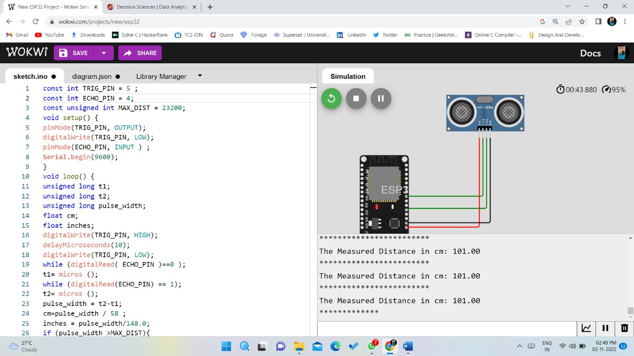

Link for WOKWI:<https://wokwi.com/projects/347207119113552468>

